77
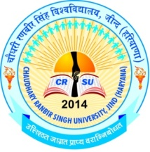
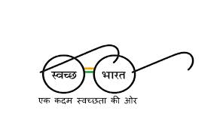
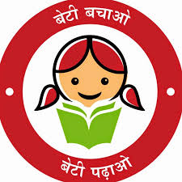

PROSPECTUS
For Admission to B.El.Ed (Regular) Four Year Professional Degree Programme
(Batch-2018-22)

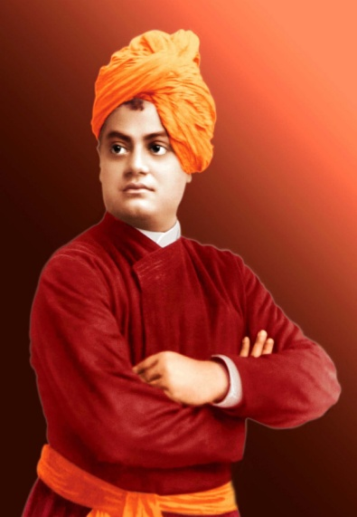
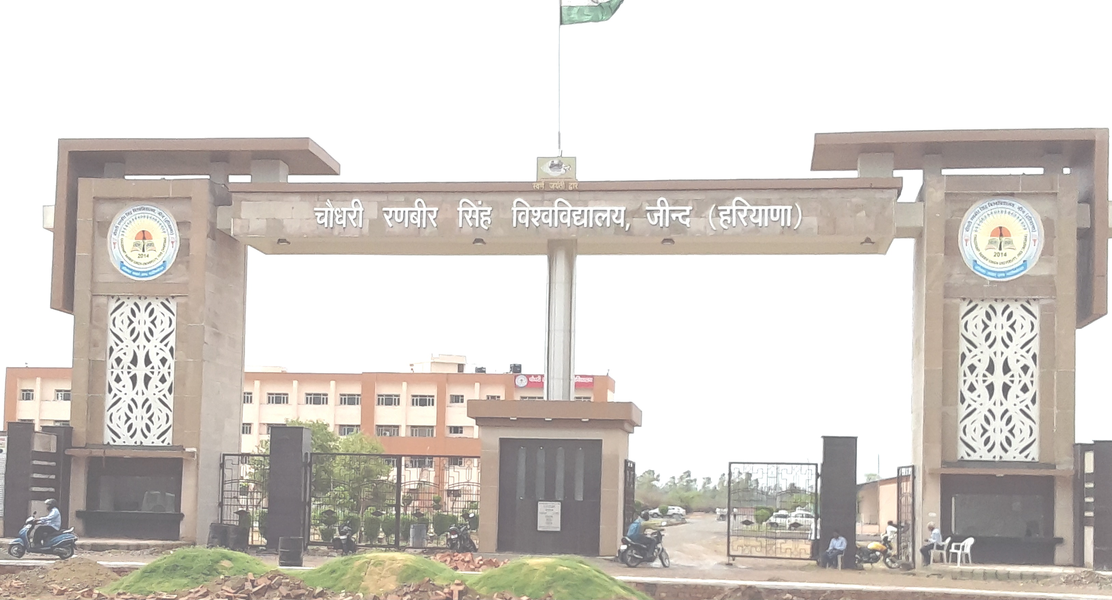

CHAUDHARY RANBIR SINGH UNIVERSITY, JIND
(Established by the State Legislature Act 28 of 2014 and recognized by UGC U/S 2(f) & 12-B of its Act 1956)
www.crsu.ac.in

AUTHORITY
The Additional Chief Secretary to Govt. of Haryana, Higher Education

(Established by the State Legislature Act 28 of 2014 and recognized by UGC U/s 2(f) & 12-B of its Act, 1956)
www.crsu.ac.in

From the Vice Chancellor’s Desk
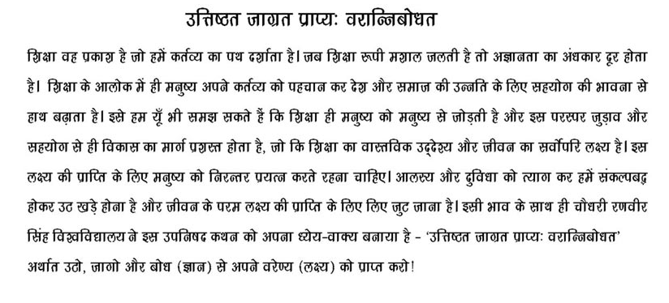
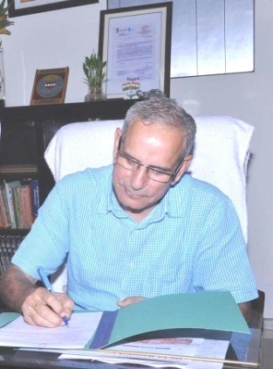
(Chaudhary Ranbir Singh University, Jind)
Born on 24 July 2014, a hardly three years old university has boast of many landmark achievements in various fields like Academics, Sports, Cultural Activities and social outreach. The University began with 16 UTD’s on campus offering 22 courses in different disciplines ranging from Diploma to Ph.D., albeit the university is situated in the vicinity of backward and rural region of Haryana, but the progress and growth it has registered during this period is tremendous, owing to which the Govt. of Haryana entrusted the University with the responsibility of conducting online admissions to B.Ed (Regular) Course for the academic session 2018-19 in all the colleges of education in Haryana. The University, besides offering various post- graduate courses is also planning to start a model B.Ed College at the University Campus. The University has developed a rich library, three well- equipped computer labs, and a Language Lab with all modern facilities and Internet connectivity through fiber Network. With the help of continuous comprehensive education system and experienced teachers, I am sure, the University will be able to produce excellent future academic cream of the crop of teachers. It is true that “No nation can rise beyond its teachers”, but it is also true that a great teacher takes pride when his students excel him. The main focus of the University will be to enable teacher trainees to realize and develop their potentials and possibilities and inculcate moral values enshrined in Indian tradition, so as to acquire a holistic vision.
It is a matter of great pride that CRS University has achieved the distinction of being the first state university of Haryana with 100% biometric attendance plus the leading digital state university of Haryana with 14th Rank among the 4500 institutes all over India promoting cashless transactions as per the vision of Hon’ble Prime Minister. In recognition to these achievements, the Hon’ble Human Resource Development Minister Govt. of India gave an outstanding award to the University for implementing “Vitiya Shaksharta Abhiyan” of Hon’ble Prime Minister. The University aspires to come upto the dreams of great personalities like Swami Vivekanand & Hon’ble Dr. APJ Abdul Kalam, former President of India to be among top 200 Universities of the World by 2020. The University is working hard towards achieving innovative thinking, a spirit of Scientific Enquiry, and Human values with Democratic Ethos so as to carpet the society instead of putting on slippers. It is committed to make its students a better human being before becoming a professional, in their respective fields.
The University is committed to promoting Government programmers like “Swachh Bharat, Swasth Bharat”, “Beti Bachao Beti Padhao”, “Yoga and Sports, Value Education” and the likes and creating a sense of awareness in the masses towards these programmes. I call upon everyone to join hands in making all these drives a mass movement.

Prof. (Dr.) R.B. Solanki
Vice Chancellor
CRS University, Jind.

CONTENTS

- Statutory Officers 1
- About the University 2-8
3. Online Admission Schedule 9
4. Instructions/Guidelines for filling online application form for admission 10
5. Important Instruction for Candidates 11
6. Instructions for College 12
7. Eligibility, Admission Process and Fee 13
8. List of Documents to be braought at the time of reporting 14

ANNEXURES
I) Instructions regarding Bonafide Residents of Haryana 15-16
II) List of the Scheduled Castes in Haryana State 17
III) List of Backward Classes in Haryana State 18
IV) Haryana Resident Certificate 19
V) Character Certificate 20
VI) Affidavit to be submitted by students against ragging at the time of admission 21-22
VII) List of Fake University / Institutes / Boards 23

Establishment of Bharat Bodh Gallary in the University

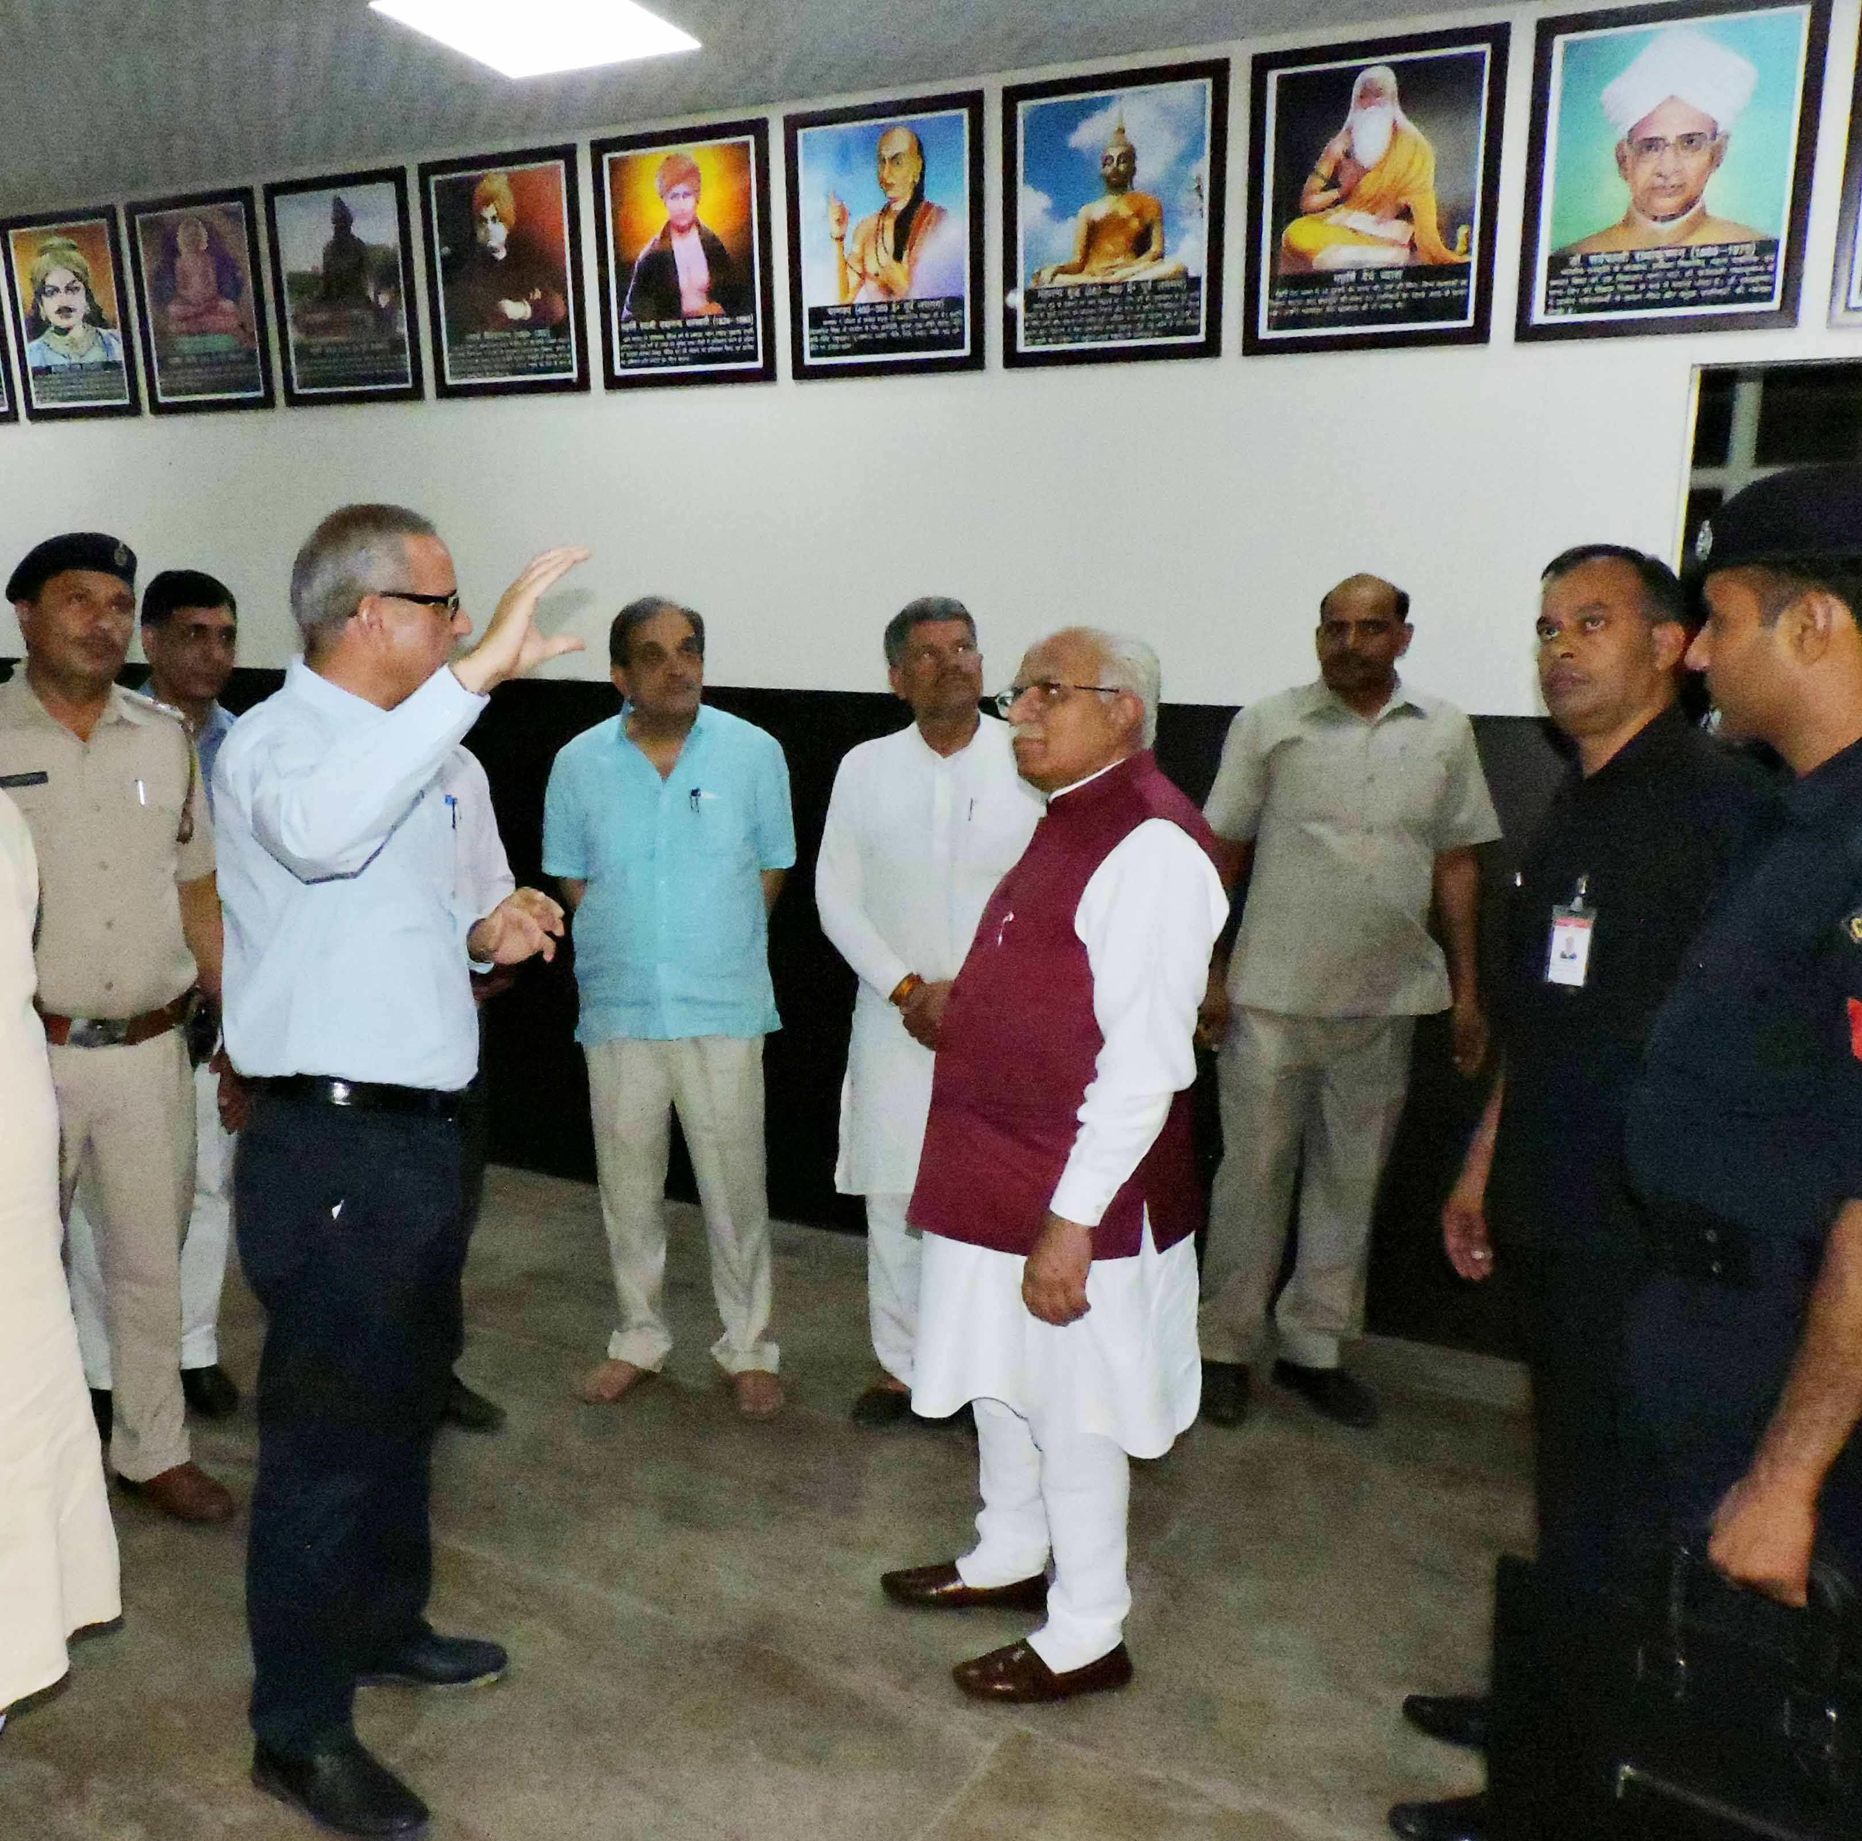

Hon’ble Chief Minister, Haryana, Sh. Manohar Lal and Hon’ble Cabinet Minister, Govt. of India, Chaudhary Birender Singh visited the Bharat Bodh Gallery on 27-05-2018.

STATUTORY OFFICERS
Hon'ble Chancellor
Shri Satyadeo Narain Arya, Governor, Haryana

Vice-Chancellor Prof. (Dr.) R.B. Solanki 01681-254569 (O)
01681-254569 (Fax)

Registrar Dr. Rajbir Singh 01681-256852(O)
01681-256852(Fax)
Proctor and Dean of Students’ Welfare Prof. Sandeep Berwal 01681-241023 (O)

Chief Warden Dr. Jyoti Sheoran 01681-241018 (O)

Dean Academic Affairs and Dean of Colleges Prof. S.K. Sinha 01681-241033 (O)
01681-241030(O)

Controller of Examinations Dr. Rajesh Kumar Bansal 01681-241003 (O)

Finance Officer Dr. Ravi Bhushan 01681-241017

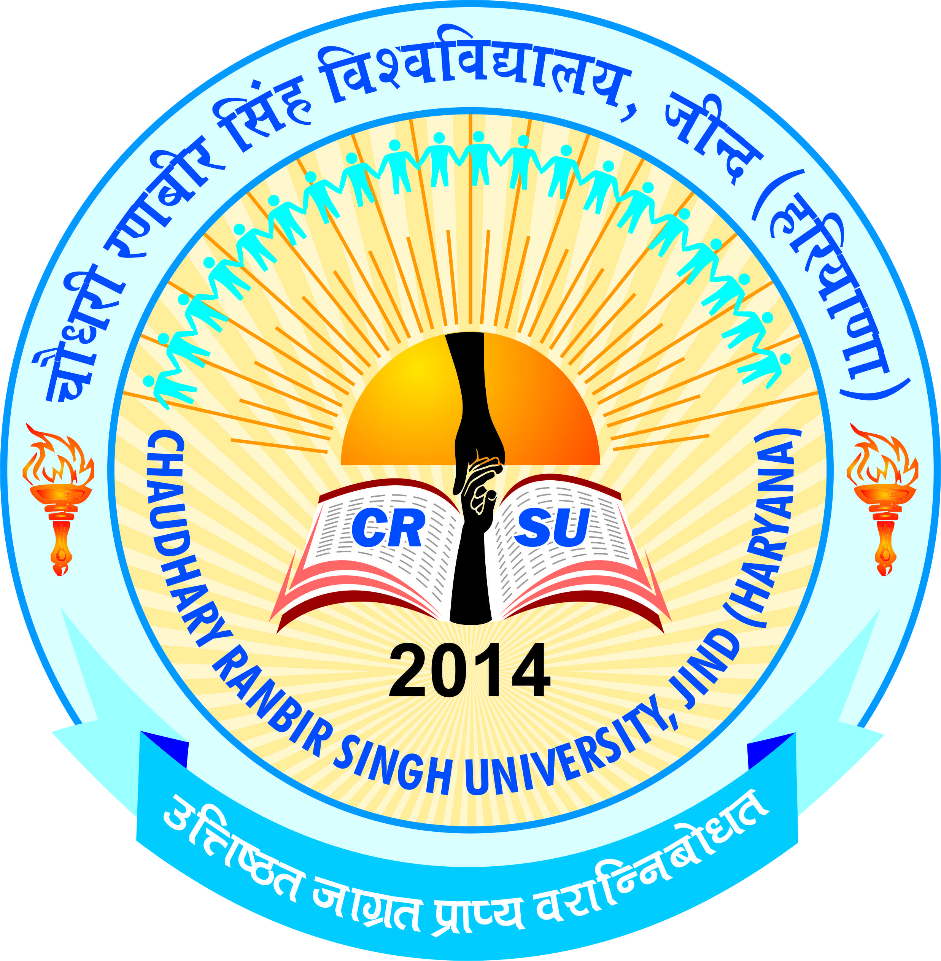 | pkS/kjh j.kchj flag fo'ofo|ky;]thUn  Chaudhary Ranbir Singh University, Jind  (Established by the State Legislature Act 28 of 2014 and recognized U/S 2(f) & 12-B by UGC Act 1956) | 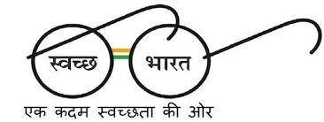

Vision of the university
- To create the most conducive ambience for the creation and dissemination of knowledge guided by innovative thinking, scientific enquiry, sublime human values, sustainable ecology, and democratic ethos.
- To be among top 200 Universities till 2020
Mission of the university
- To celebrate the national traditions, culture, heritage and folklore.
- To focus on quality, relevance and innovation in each discipline.
- To establish linkages with reputed organisations at national and international level for the exchange of ideas and collaborative research.
- Student-centric and participatory academic environment.
- To maintain coordination with various stakeholders including Government, Industry, Community etc.
- To inculcate sound human values
- To practice multidisciplinary and inter-disciplinary approach in dissemination of knowledge.
- To impart soft skills to ensure employability.
- Zero tolerance for indiscipline and irresponsible life style.
- To create world class infrastructure to facilitate students to engage in rigorous academic originality in research activities.
- To contribute to the development of the neighbouring community through social outreach initiatives.

UNIVERSITY PROFILE
Established by the State Legislature Act 28 of 2014 on July 24, 2014, CSRU has a sprawling campus of 75 acres situated 2 kilometres from Gohana Bypass, Jind. The university was established with the vision of imparting quality education by creating most conducive ambience for the production and dissemination of knowledge guided by innovative thinking, scientific enquiry, sublime human values, sustainable ecology, and democratic ethos. The aim of the University is the cultivation of citizens with a rich awareness of our heritage to lead and serve in every sphere of human activity. Working under the leadership of eminent educationists and social reformers, Hon'ble Chancellor Shri Satyadeo Narain Arya and dedicated, dynamic and devoted personality Vice- Chancellor Prof. R.B. Solanki, the University is heading towards realization of its vision and the goal of being in the world ranking by 2020.
The University is affiliated u/s 2(f) and 12 (B) of the UGC Act, 1956 vide letter no. 9-12/2014(CPP-I/PU) dated 26 September, 2014 and is also a member of the Association of Indian Universities. In a short span of four years, the university has many achievements to its credit. The First Convocation of the University was held on April 18, 2017. Prof. Kaptan Singh Solanki, Governor of Haryana was the Chief Guest and delivered the Convocation Address. Ch. Birender Singh, Steel Minister, Government of India, Sh. Ramesh Kaushik, Member of Parliament, Smt. Prem Lata, MLA and Sh. Jasbir Deswal, MLA were also graced the convocation as Guests of Honour. The university gave 14 Gold Medals, 13 M.Phil, 289 Post Graduates and 289 Under Graduates Degrees were awarded during the Convocation.
In addition to the academics the students are also encouraged to participate in sports events and extracurricular activities at the campus as well as outside the campus the enable their wholesome personality development.
The university has a newly constructed academic block with latest infrastructure and newly constructed Laxmi Bai Girls Hostel with ultra-modern facilities. The central library of the university has the stock of approximately 16000 books. It subscribes to National and International refereed journals, magazines and periodicals and also subscribes many Hindi and English newspapers. Round the clock internet facility is also available in the library premises. The university has an impressive Language Lab which is open for all the students of the university to help them to improve their communication skills. The university also has a Computer lab well equipped with the latest software and is networked with 32 mbps internet speed with fiber optical device. The Psychology lab of the university is spacious and fully equipped with latest equipment to carry out the tests. The Conference room of the university is equipped with world class facilities with a seating capacity of 40 persons. The construction for the extension of academic block, Second Computer Lab, Administrative Block, Boys Hostel, Sports Stadium and residential quarters for faculty is in full swing. The students of this university have shown commendable results in academics as well as co-curricular activities. With the present pace of progress, the university looks forward to having a promising future.

UNIVERSITY LIBRARY
Libraries are an integral part of all educational institutes in India. The library of the university is well equipped with large numbers of books. The library has subscribed many newspapers. It is planned to shift the library to its new building from the coming session i.e. 2018-19. It will be well equipped with the modern technology and infrastructure. Recently, an E-Kiosk system has also been installed for the convenience of the students as well as faculty members. The library also provides AC reading rooms where the readers can study peacefully. The library remains open from 9.00 A.M. to 5.00 P.M. The library recorded about 500 users including students and staff of the university.

LAXMI BAI GIRLS' HOSTEL AND CHHATRAPATI SHIVAJI BOYS' HOSTEL
The University has one hostel for Girls named after the Queen of Jhansi, Rani Laxmi Bai. It was inaugurated by Hon'ble Governor Prof. Kaptan Singh Solanki on 12th November, 2014. It has the capacity of accommodating 240 girls. The University has one Hostel for Boys named after the Founder of Maratha Empire, Chhatrapti Shivaji Maharaj (Shivaji Raje Bhosale). It was inaugurated by Hon’ble Chief Minister Sh. Manohar Lal on dated 27th May, 2018. It has the capacity of accommodating 180 boys. The hostel is provided with electronic gadgets including electric geysers, 32" Plasma TVs along with Dish/DTH facility and water cooler with RO system. The hostels subscribe to several national and regional dailies and magazines for enabling the students to know what is happening around the world. Sport facilities for girls include table tennis and badminton court, volley ball court, gym and different indoor games like carom-board and chess etc. Medical facilities to all hostel residents are provided through the University Health Centre located in the Hostel premises. The University also has a Horticulture Club maintained by the girls of the Hostel. Beauty and skin care clinic has been established for the grooming of all students. The hostel on the campus operates its own mess providing hygienic and nutritious meals with a varied menu. In view of the large number of students applying for hostel accommodation, the university allows hostel to the students on the basis of merit.

UNIVERSITY HEALTH CENTRE
The Health Centre located in Laxmi Bai Girls Hostel has sufficient space for a dispensary with patient Beds and stools with drop stand. The centre has a visiting doctor and a nurse and provides medical consultation and free medicines to all students and staff. The health centre is well equipped with all basic apparatus and general medicines. The Health Centre also provides first line of treatment in emergency cases. The process for the full-fledged development of university health centre is in process and will be accomplished soon.

UNIVERSITY COMPUTER & INFORMATICS CENTRE (UCIC)
The University Computer & Informatics Centre (UCIC) is steadily evolving the university as "Digital University" and working rigorously to provide the excellent infrastructure facilities with High end systems controlled by Dell Make power Server. Central UPS with a power back up of 8 hours is controlling all the All-In-One Systems connected via optical fiber LAN covering the whole Campus. 24 X 7 Internet facility with 32 Mbps is available to students as well as staff. UCIC is continuously monitoring and updating all the information on university website as well as on various social media portals. It also purports to automate administrative and secretarial wings of the university with the aim to cater the needs of the entire university. University Computer & Informatics Centre (UCIC) is providing opportunity to enhance professional knowledge of students.

LANGUAGE LAB
The Language lab has been established to improve communication skills of the students. The Lab is equipped with latest software related to English Language and Communication. It provides a host of opportunities for students to work with online exercise sheets and virtual practice sessions, thus enabling them to learn language in a simulated environment.

PANDIT DEEN DAYAL UPADHAYAYA CENTRE
In order to prepare students for varied professional fields, the university has established DDUC for university students as well as students/professionals from other institutions. The Cell has implemented the following schemes (i) Free UGC NET coaching (ii) Personality Development Capsule (iii) SSB coaching. Faculty members, teachers from other universities and experts from different fields are also invited to deliver extension lectures in the centre.
SC/ST CELL
The SC/ST Cell has been established for the welfare of SC/ST students of the university as per the instructions of the UGC/State Government. The Cell also functions as a Grievances Redressal Cell to redress the grievances of the SC/ST students and employees of the university. It also counsels them in solving their academic as well as administrative problems. The main objective of the SC/ST Cell is to ensure proper implementation of various schemes of University Grants Commission/Government of India/State Government introduced from time to time.

GUIDANCE AND COUNSELLING CELL
The university has constituted Guidance and Counseling cell to assist the students in career areas (Knowledge of different career options through Career Talks). It also helps students in Personal areas (Stress, anxiety, lack of self- confidence, communication skills, Development of Positive attitude, Assertiveness Training, etc.).

EQUAL OPPORTUNITY CELL
The university has constituted Equal opportunity cell to provide equal opportunity to all including the persons with disability. In addition, it will also examine all the possible ways in which SC/ST, OBC and all other minority groups could be helped.

VIGILANCE CELL
The university has constituted Vigilance cell to activate vigilance machinery for investigating complaints and sensitizing the university community against corruption and corrupt practices. The main objective of this cell is to prevent the possibilities of corruption and to encourage a culture of honesty and integrity.

RESEARCH CELL
The university has constituted the Research Cell to facilitate and promote quality research in emerging areas of higher education with focus on new frontiers and to act as a knowledge power- house capable of contributing to the national development and welfare of the society.

INTERNAL QUALITY ASSURANCE CELL
The university has constituted the Internal Quality Assurance Cell (IQAC) for planning, guiding and monitoring quality enhancement activities of the University. The cell works to instill the spirit of quality consciousness and continuous improvement of academic and administrative performance of the University and to promote measures for institutional functioning towards quality enhancement through internalization of quality culture and institutionalization of best practices. In order to enhance the academic quality of the UTDs, the auditing of the departments is carried out from time to time. The university invites experts who suggest areas where the department needs to improve. All the internal audits are discussed in the meetings chaired by the Vice Chancellor, who provides directions for the implementation of the suggestions of the experts given in the audits.

DIRECTORATE OF YOUTH AND CULTURAL AFFAIRS
Directorate of Youth Welfare aims at ensuring the welfare of students by conceiving and organizing programmes for the establishment of a healthy cultural environment in the university. It motivates students to participate in various cultural activities to ensure their holistic development. Besides celebration of national festivals, the Directorate also organizes Talent Hunt Competitions.

SPORTS ACTIVITIES
Sports activities of the university are being run under the Sports Council. The university has the following playfields: Handball (1), Football (1), Volleyball (1), Netball (1), Korfball (1), Kho- Kho (1), Kabaddi(1), & Athletic Track 400 mtrs. The university is going to have its Sports Stadium soon. The university provides different sports facilities to its players taking part in the inter university tournaments like free TA & DA, sport kit &track suit, free medical facility and scholarship to the players winning positions in these tournaments. In recently completed Asian game 2018 (18 Aug 2018-2 Sept 2018) at Jakarta, Indonesia. One student of Department of Education namely Ms. Ritu participated as a member of Handball team and represent the Country.
NATIONAL SERVICE SCHEME
National Service Scheme (NSS) promotes the spirit of voluntary work among the students and teachers through sustained community interactions. It brings academic institutions near to the society. It shows how to combine knowledge and action to achieve results, which are desirable for community development. NSS at Chaudhary Ranbir Singh University was established with the objective of providing the youth an opportunity to develop their overall personality by taking part in various Social Service Schemes. The University has initiated the process of students' enrolment. Students will be given opportunity to participate in state and national level camps. Merit certificates are provided to students, who perform well in the camps. The NSS unit organized special camp on digital financial literacy and four students also received appreciation from MHRD, Government of India.

BHARAT BODH GALLERY
The University has established Bharat Bodh Gallery for inculcating the values of National Pride and National Commitment, Teaching to live together for Social Harmony, Education about Bhartiya Sanskriti, Bhartiya Gyan and Gouravshali Bhartiya Itihas among students.

Highlights of Activities

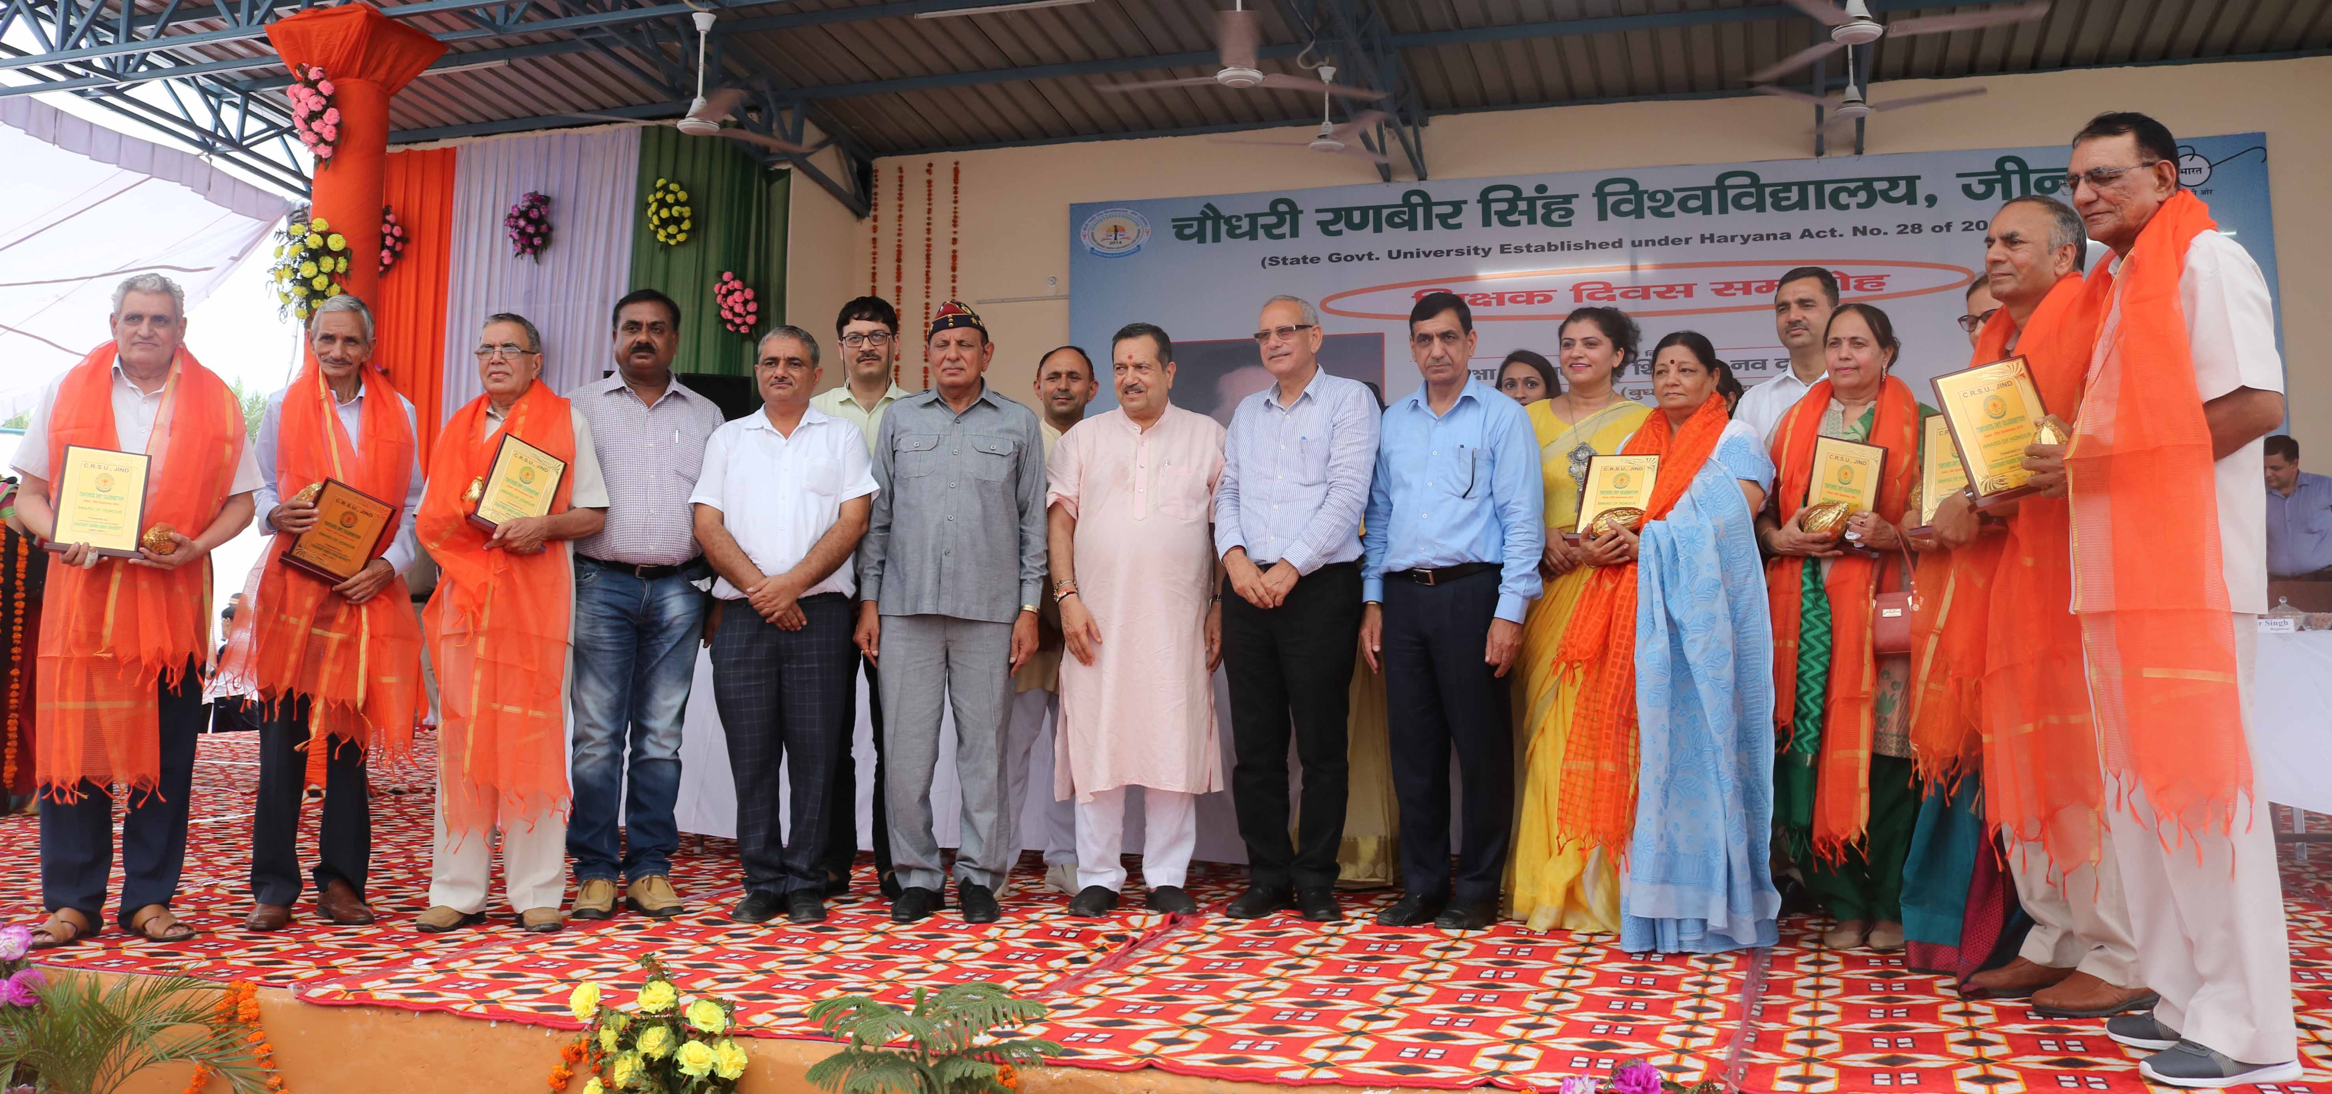
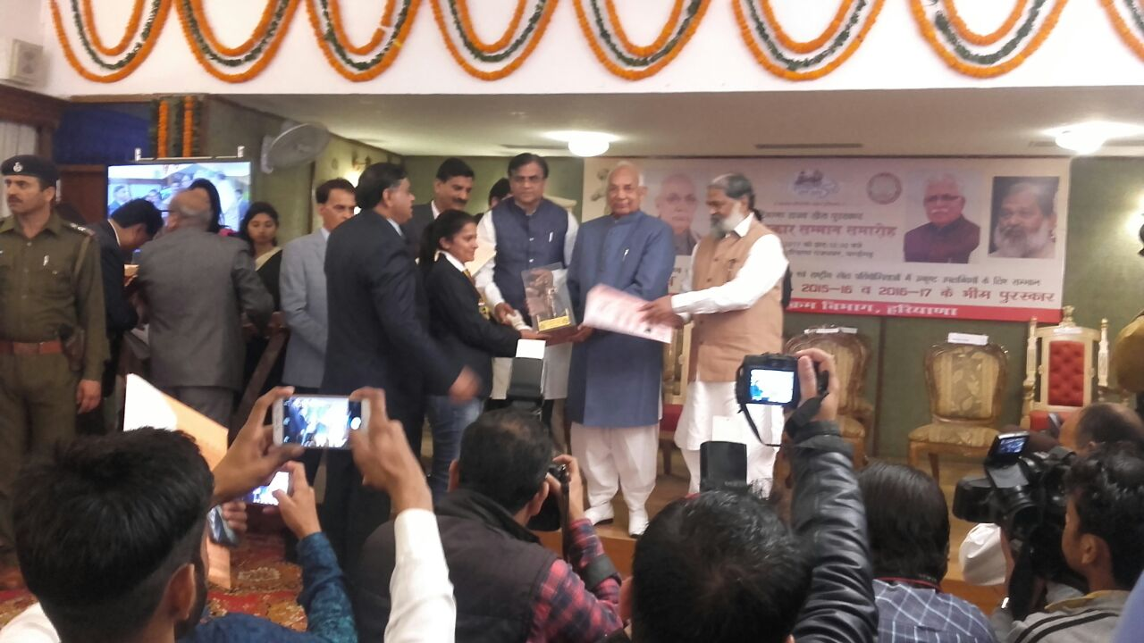

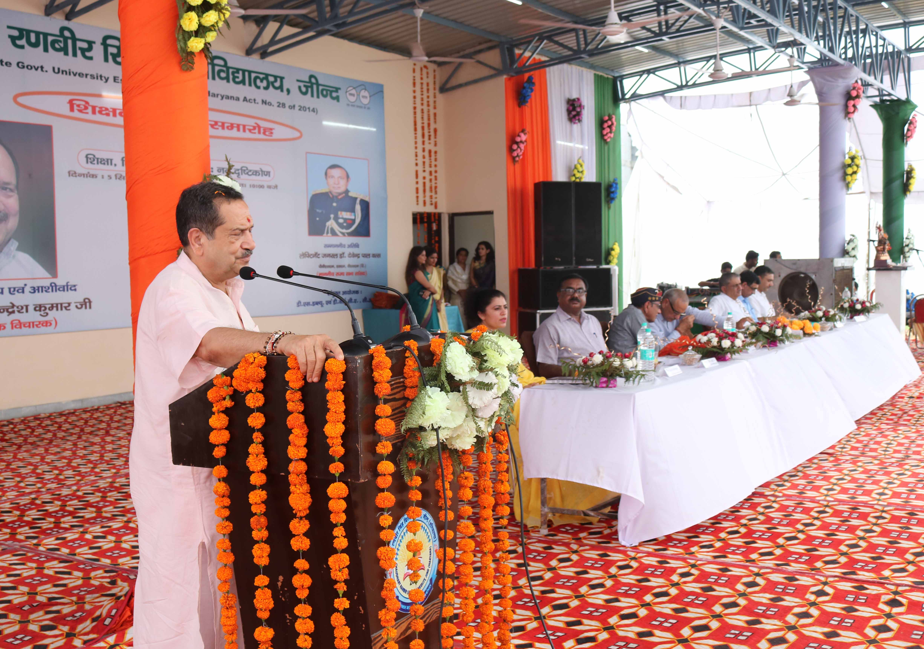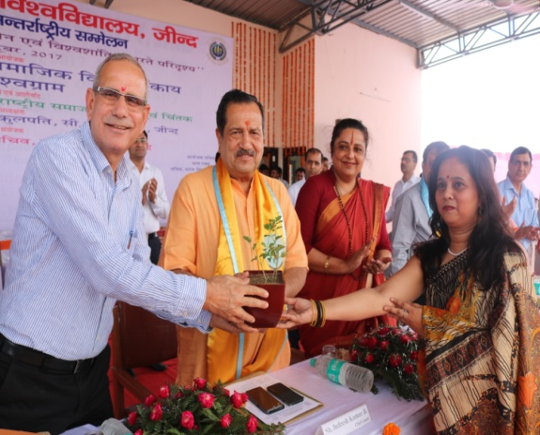
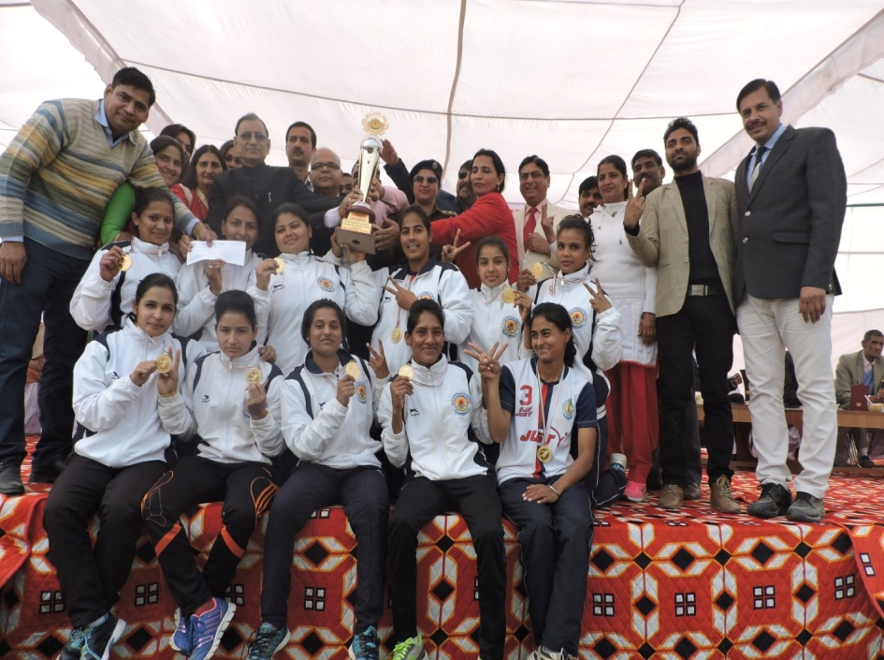

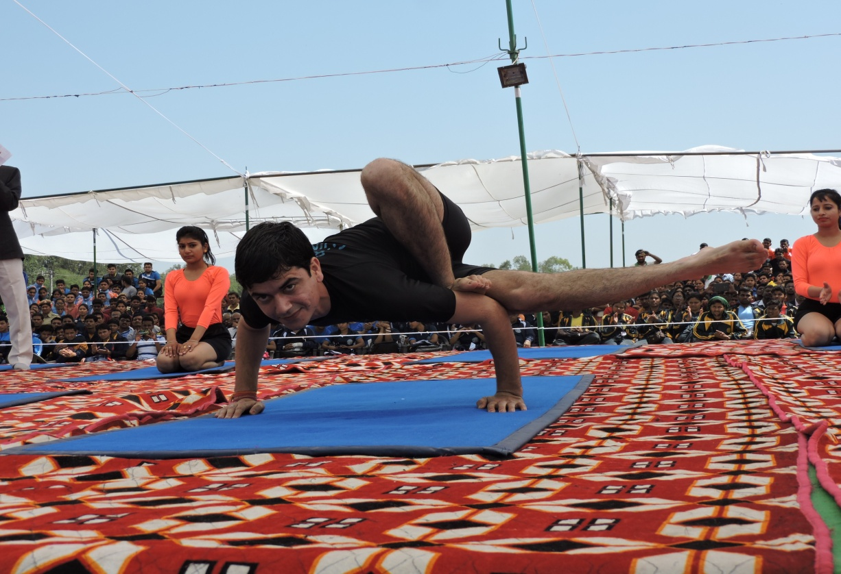
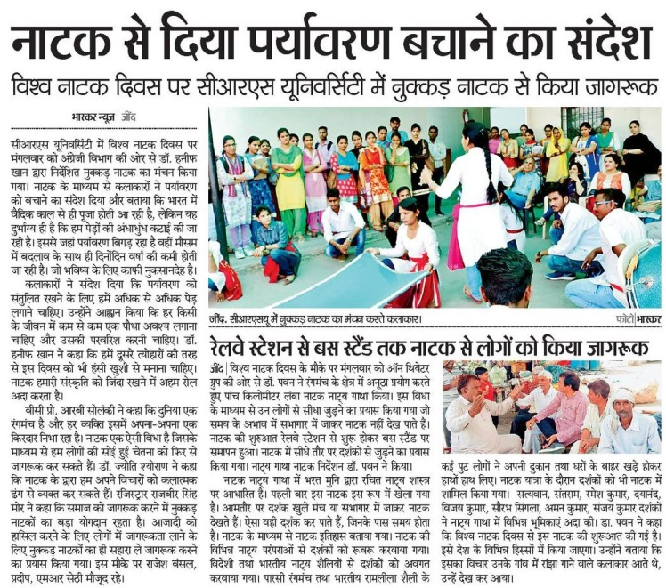

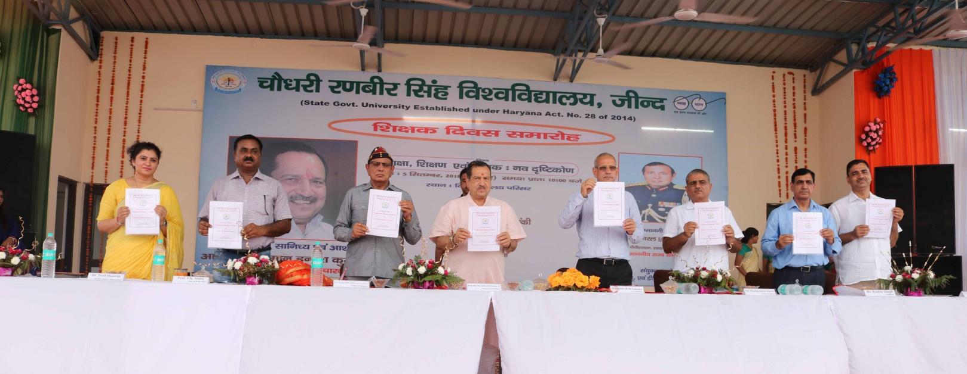
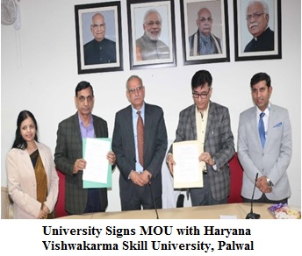
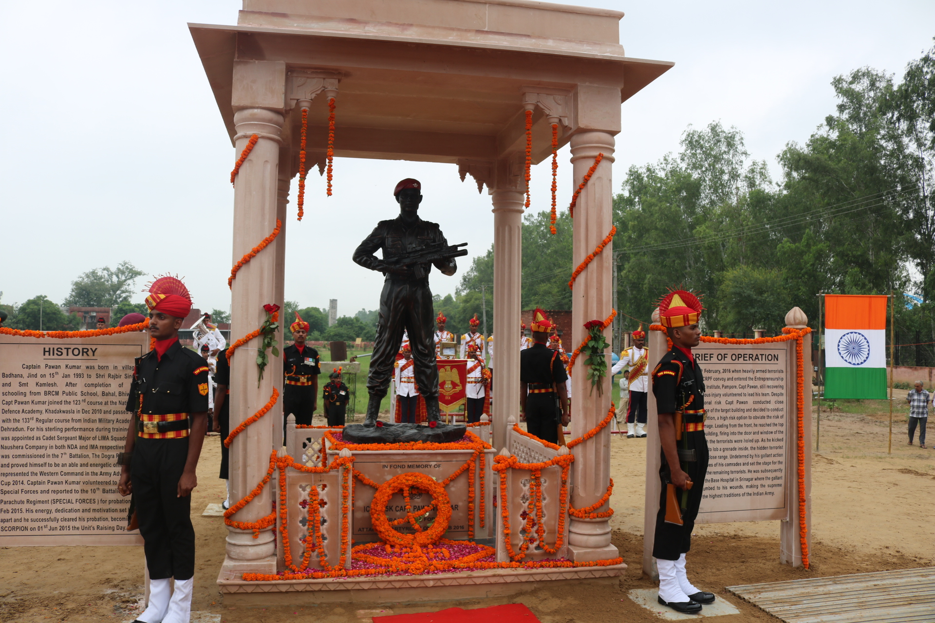

1st University Youth Festival “AAGAAZ”
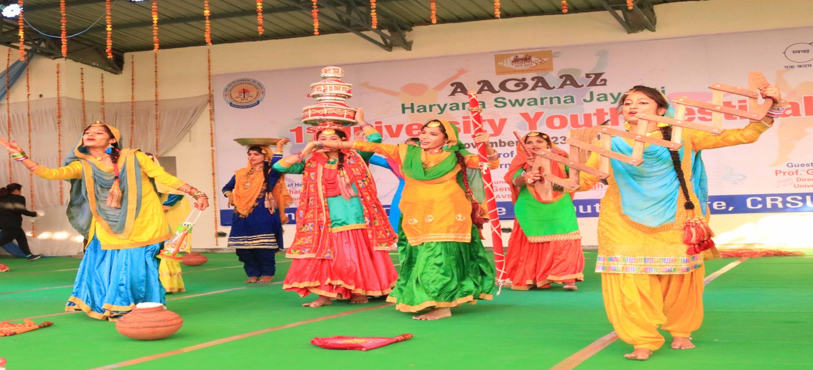

ONLINE ADMISSION SCHEDULE
B.El.Ed four year Professional Degree Programme

Details of Admission schedule | Online applications forms are invited for B.El.Ed four year Professional Degree Programme under Self Finance Scheme (SFS) only
Online availability of Prospectus, online Registration, acceptance of 15.07.2015 25.07.2015  Applications, Deposition of Registration (upto 5-00 p.m.) (upto 5-00 p.m.)  as well as counselling fee Rs. 500/- (Rs. 125/- for SC/PWD of Haryana) must be deposited upto 12-10-2018 | Opening Date of Online Registration: 26-09-2018  Closing Date of Online Registration : 12-10-2018
Display of First Merit List | 13-10-2018
Document Verification & Fee Submission (First Merit List) | 15-10-2018
Display of Second Merit List | 16-10-2018
Document Verification & Fee Submission (Second Merit List) | 17-10-2018
Display of Third Merit List | 19-10-2018
Document Verification & Fee Submission (Third Merit List) | 20-10-2018
Physical Presence, if seats remain vacant | 22-10-2018 upto 11:00 a.m.
Display of Merit List (Physical Presence) | 22-10-2018 on 12:00 noon
Document Verification & Fee Submission (Physical Presence) | 22-10-2018 upto 4:00 p.m.
Classes will start for the session 2018-19 | 13-10-2018
Tentative Date for Examination of 1st Semester | February, 2019

University Contact No. – 01681-241027.
Email: academic@crsu.ac.in
Note:
Cut off date for eligibility will be the last date/time of online choice filling. There will be
no admission to B.El.Ed four year professional Degree Programme after 22-10-2018.

INSTRUCTIONS/GUIDELINES FOR FILLING ONLINE
APPLICATION FORM FOR ADMISSION
- The admissions are available for girls only. For filling online application form go to website www.crsu.ac.in.
2. Before applying online, a candidate should have: -
(i) Scanned copy of your Photograph and Signature
(ii) Mobile Number & E-mail id
(iii) Keep the necessary details/document(s) ready (such as DMC of Matriculation, Senior Secondary etc.)
- University help desk has been established for the applicant on the first floor of the academic building in the University Computer Information Centre Lab for filling online application form.
- Before filling the Online Application Form, the candidates should read the Prospectus carefully.
- All the entries in the Application Form should be filled. No entry should be left unfilled.
- Candidates must ensure that they have all the relevant certificate(s) from the appropriate competent authority approved and notified by the Govt. of Haryana.
- Applications which do not have the required documents will be treated as incomplete and such applications may not be considered for admission.
- No registration will be allowed before or after stipulated registration dates.
- On application form, items marked with * are compulsorily to be filled in.
- Candidate will not be informed about any activity by post. It is solely Candidate’s responsibility to check web site for all activities.
- A tentative merit list of students will be uploaded on the College website on the dates mentioned in this prospectus for batch 2018-22 and also displayed on the Notice Board of the concerned College.
- Candidates as per tentative merit list shall reach the concerned College for verification of documents along with their original Documents, a copy of all documents (like downloaded application form, a paid copy of e-Challan of application fee, additional documents list is available on website) and Admission fee of the course/programme as mentioned in the Admission Brochure. The tentative Merit list may change after verification of original documents.
- Stay connected with http:/www.crsu.ac.in for updates. For any support you may contact to 01681-241021,241008 or mail us at admission@crsu.ac.in
- The Admission to B.El.Ed four year Professional Degree Programme for the session 2018-19 will be made on the basis of inter-se merit of percentage of the Qualifying Examination .
- No one who is already in employment (whole time or part time or in honorary capacity) shall be
admitted to the B.El.Ed four year Professional Degree Programme without taking leave from the employer for full duration of the course.
- It will be the responsibility of the candidate to ensure eligibility for admission before applying for
the course. If on verification at a later stage, it is found that a candidate does not fulfil the
eligibility conditions, his/her candidature will be cancelled and the fee deposited byhis/her shallbe forfeited
- The candidates interested in seeking admission in B.El.Ed four year Professional Degree Programme only opt for below stated College-
- Nakshatra Vidyapeeth, Khudana, Mohindergarh : 50 seats
- R.S. Memorial College of Education, Buana Lakhu, Panipat : 50 seats
IMPORTANT INSTRUCTIONS FOR CANDIDATES

- Before filling the Admission Form the candidates are required to read the Prospectus carefully.
- No column should be left blank in Admission Form; write N.A. against the column which is not applicable otherwise it will be considered as incomplete and liable to be rejected.
- The admissions shall be made on the basis of merit of qualifying examination.
- Candidates having compartment in the qualifying examination shall not be allowed admission in the course.
- If the last date of receipt of Application Form and last date for depositing the dues falls on a holiday or that day is declared holiday by the University, the next working day will be considered the last day for the purpose.
- Each admitted student shall have to furnish Self Declaration by his/her as per specimen given at ANNEXURE-VI that he/she was never found guilty of ragging and shall not indulge in any act of ragging. At the time of admission every candidate shall be required to give an undertaking of good conduct & behavior and not to indulge in ragging. If a candidate after her admission is found indulging in any kind of ragging, her admission is liable to be cancelled.

- Candidates seeking admission in educational institutions located in Haryana may not be required to produce Resident Certificate, if they have passed the examination from a school/college situated in Haryana. For this purpose, a certificate of the Principal/Headmaster from concerned institution where the children/wards studied last should be considered sufficient. The Principal/Headmaster of the institution shall be competent to issue such certificate, which shouldbe sufficient.

- Merit list will be displayed on the Notice Board of the College concerned. It shall be the sole responsibility of the candidates to remain in touch with the College concerned for keeping track of progress of admissions and should visit the university website www.crsu.ac.in on regular basis. No separate communication in this regard will be sent to the candidates by the University.

- Use of Alcohol and Drugs is prohibited in the College Campus. Every student must observe discipline on the Campus failing which strict action will be taken against his/her.

- A student should always wear his/her ID card in the campus and must be displayed. The same should be shown when demanded by the College officials.

- If the concerned authorities are not satisfied with the character/past behavior/antecedents of a candidate, they may refuse to admit his/her to any course of study in the College in order to ensure academic standards, discipline and peaceful atmosphere in the College.

- In case any candidate is found to have supplied false information, certificates, documents etc. or is found to have withheld or concealed some information in his/her Application Form, he/she shall be liable to be debarred from admission to the course.

- If a candidate is admitted on the basis of the information submitted by his/her, which is found to be incorrect or false at a later stage, his/her admission will be cancelled and all fees and other dues paid by his/her shall be forfeited. The College may also take further action, as deemed fit, against the candidate and his/her guardian.

- Any legal dispute relating to admission of students will be subject to Courts at Jind or Courts having jurisdiction in Jind.

INSTRUCTIONS FOR THE COLLEGES

1. The Colleges shall constitute an Admission Committee to be appointed by the Principal
from amongst the teachers of concerned College.

2.Verification of the documents of the candidate will be done by the respective Admission
Committee of College at the time of reporting for admission, by comparing with the original
certificates against which candidate has been allotted seat. Any entry or information
filled/ made by the candidate, if found to be false, shall entail automatic cancellation of admission.

3.The admission committee may ensure that the Candidate has deposited the fee as per her
entitlement.

4.Online reporting should be done as and when candidate reports at College and not on the last
date of admission.

5. The College is required to update admission status online on www.crsu.ac.in.

6. All admissions by colleges are to be updated/ reported online, as and when they admit the
candidates. No permission of any kind would be provided for admitting students, if status of admission not reported online as per schedule.

7.Information about only those candidates, whose admission status has seen reported online, will
be forwarded to Registration Branch of University.

8.Responsibility for any wrong/irregular/excess admission will entirely rest upon the Principal
concerned /Secretary of the College Management Committee.

9.Admission of candidates who have passed their qualifying examination from other board
shall be provisional subject to verification of the eligibility by the Registration Branch of the
university.

10.All the rules and regulations for submission of Registration Return of students by the colleges will be applicable as per the rules of the University.

11.Every College must give accurate information on its website regarding human and instructional resources alongwith subjects in which teachers are available in the College.

12.Under no circumstances the original certificates of the candidate should be retained by the colleges.
The candidate seeking admission will submit two sets of her documents/ certificates duly
self attested by Candidate, at the time of reporting in the college. The Principal of the college
will authenticate these documents/ certificates after comparing these from the originals and the
originals will be returned to the candidate. One set of these documents/ certificates thus
authenticated by the college shall be deposited in the University, for the purpose of
registration, for which no original certificate shall be demanded.Anyhow, if the University, so desires the original certificates from the candidate can be demanded through
the College of his/her admission for any purpose what so ever these may be.

- In addition to NCTE guidelines for resource centre/labs, the Colleges should have laboratories as per UGC guidelines for Under Graduate programmes.

- In case of any discrepancy/doubt the guidelines of NCTE shall be looked into and are applicable.
Eligibility, Admission Process and Fee for B.El.Ed four year professional degree programme

- Eligibility: Candidates seeking admission to the B.El.Ed Programme should have cleared the 10+2/Senior Secondary Examination or any other examination recognized as equivalent thereto with a minimum aggregate of 50% marks.
Note:
(i) There shall be no rounding off of percentage of marks of the qualifying examination from 0.5% and above to next higher number for determining the eligibility i.e. 49.5% and above will not be rounded off to 50%.
(ii) 47.5% marks for SC candidates as per Govt. of Haryana letter no. 22/129/2013-1GSIII dated 16-07-2014 issued by Superintendent General Services-III O/o Chief Secretary Govt. of Haryana.
(iii) 47.5% marks for differently abled candidates.
(iv) Compartmental candidates will not be allowed admission in B.El.Ed four-year professional Degree Programme in any case.

- Admission Process: Admission to the B.El.Ed four-year degree programme shall be made on merit on the basis of marks obtained in the qualifying examination (i.e. 10+2/Senior Secondary Examination).

- Fee : Self-Financing College(s) of Education:- Rs. 35,000 (per annum)

FEE STRUCTURE (Per annum)

In addition to the above fee, other annual charges as prescribed by the CRS University are given below:
a. Development Fund Rs. 2000/-
b.Regn./Enrolment Fee Rs. 1000/-
c.Examination Fees Rs. 800/-
d.Dr. R.K. Foundation Fee Rs. 70/-
e.University Sports Fee Rs. 200/-
(Rs. 120/- to be remitted to the University)
f. Youth Welfare Fee Rs. 100/-
(Rs. 50/- to be remitted to the University)
g.N.S.S. Fee Rs. 50/-
(Rs.25/- to be remitted to the University).
h.Youth Red Cross Fund Rs. 60/-
(Rs. 30/- to be remitted to the University)
Total Rs. 4280/-
Share of fee to be withheld by the College (-) 185/-

Total Balance Feet to be remitted to the University Rs. 4095/- per Student

List of documents to be brought at the time of reporting
The candidates, at the time of reporting must bring the following Original Certificates/ Documents/
Testimonials alongwith two sets of duly attested photocopies of these with them.Any candidate,
who fails to produce any of the required Certificate/Document /Testimonial at the time of reporting
the institution, will forfeit his/her claim to admission.
- Matriculation/ High School Certificate
- 10+2/Intermediate/Senior Secondary School Examination Certificate &
Detailed Marks Card.
(iii) Character Certificate:
(a)Regular Candidates: The candidates who have passed their qualifying exam from School as regular students are required to submit the Character Certificate as perAnnexure- V.
(b) Private Candidates:Candidates, who have passed the qualifying examination as private
candidates should submit their Character Certificate, duly signed by a Notary Public.
(c) Gaps in study:Candidate who have gaps in their academic career after the qualifying
exam., must furnish a gap certificate, in the form of affidavit on non-judicial stamp paper or
certificate from the employer (if in the service) and should also furnish separately the character
certificate of gap period duly attested by Notary Public.
(iv) Residents Certificate as per Annexure-IV, if applicable: Candidates, who have passed their
qualifying examination from a Board located in the State of Haryana will be deemed to be
Haryana residents and will not be required to submit certificates of bonafide residents of Haryana.
(v) ProvisionalAllotment Letter.
(vi) Original Receipt of Registration & Counseling Fee.
(vii) Print out of OnlineApplication form alongwith their locked Choice.

ANNEXURE-I
Instructions regarding Bonafide Residents of Haryana issued vide letter No.62/17/95-6 GSI dated
3rd October, 1996, No.62/32/2000-6GSI dated 23rd May, 2003, No.62/27/2003-6GSI dated 29th
July, 2003 and No.62/62/2011-6GSI dated 17th January, 2012 by the Chief Secretary to Government,
Haryana.
Subject: Bonafide residents of Haryana - Guidelines regarding.
- I am directed to invite your attention to Haryana Govt. letters noted in the margin on the subject
noted above vide which the instructions were issued regarding simplification of procedure for
obtaining the certificate of Domicile for the purpose of admission to educational institution (including
technical/medical institution). The matter has been reconsidered in the light of judgment delivered
by the Hon'ble Supreme Court of India in the case of Dr. Pradeep Jain vs. Union of India and
others reported as AIR 1984-SC-1421, wherein it has been held that instead of the word
'Domicile' the word 'Resident' be used in the instructions issued by the State Government and it
has been decided to revise the Government instructions. Henceforth, the following categories of
persons would be eligible for the grant of Resident Certificate:-
- Candidates, who have passed the examination qualifying there for selection in an institution from
a school/college in Haryana.
(II) Children/Wards (if parents are not living)/Dependents: -
- of the regular employees of Haryana State posted in or outside Haryana State or working
on deputation;
(ii) of the regular employees of the statutory bodies/corporations established by or under an
act of the State of Haryana who are posted in Chandigarh or in Haryana or outside Haryana.
(iii) of the regular employees of the Government of India posted in Chandigarh or in Haryana
in connection with the affairs of the Haryana Government;
(III) Children/wards (if parents not living)/dependents of persons who after retirement have permanently
settled in Haryana and draw their pensions from the treasuries situated in the State of Haryana.
(IV) Children/wards (if parents are not living)/dependents of pensioners of Haryana Government
irrespective of the fact that the original home of the retiree is in a state other than Haryana or he
has settled after retirement in or outside Haryana,
(V) Children/Wards (if parents are not living)/dependents of persons, who have permanent home in
Haryana and include persons who have been residing in Haryana for a period of not less than 15
years or who have permanent home in Haryana but on account of their occupation they are living
outside Haryana;
(VI) The wives of such persons who are bonafide residents of Haryana irrespective of the fact that
they had belonged to any other State before marriage;

(VII) Persons who were born in Haryana and produce a certificate to that effect; provided that the
parents/guardians (if parents are not living) of persons belonging to any one of the above mentioned
categories are :
(i) Citizen of India;
(b) Produce an affidavit to the effect that they or their children/wards (if parents are not living)/
dependents have not obtained the benefit of Resident in any other State.

(VIII) Children & Wards of the accredited journalists residing at Chandigarh and recognized by Govt.
of Haryana.
2. All candidates claiming to be bonafide residents of Haryana should produce a Haryana Resident
Certificate signed by the District Magistrate/GeneralAssistant to Deputy Commissioner or Sub-
Divisional Officer (Civil) of the District/Sub-Divisions/Tehsildars of Revenue to which the
candidates belong. Resident Certificates in respect of elsewhere or in respect of the Children/
Wards/Dependents of Haryana Govt. employees who are posted at Chandigarh, Delhi or
elsewhere or in respect of Children/Wards/Dependents of pensioners of Haryana Govt. or in
respect of the Children/Wards/Department of the employees of the Government of India posted
at Chandigarh or in Haryana in connection with the affairs of Haryana Government, or in respect
of Children/Wards/Dependents of the employees and retirees of the Statutory Bodies/Corporations
of Haryana established by or under an Act of the State of Haryana or a Central Act and located
at Chandigarh, Haryana or outside Haryana, should be by their respective Heads of Departments.
3. Candidates seeking admission in educational institutions (including medical and technical institutions)
located in Haryana may not be required to produce Resident Certificate, if they have passed the
examination from a school/college situated in Haryana. For this purpose, a certificate of the
Principal/Headmaster from concerned institution where the children/wards studied last should
be considered sufficient. The Principal/Headmaster of the institution shall be competent to issue
such certificate, which should be sufficient.
4. If a candidate is admitted on the basis of claim that he belongs to the State of Haryana but at any
subsequent time is discovered that his claim was false, the student shall be removed from the
institution, all fees and other dues paid up to the date of such removal shall be confiscated. The
Principal/Headmaster may take such other action against the student and his/her parents/guardians
as he may deem proper in the circumstances of any particular case.
5. The children/wards/dependents of the employees of Punjab & Haryana High Court, who are
discharging their duties in connection with the affairs of the State of Haryana and have not
availed facility from their parent State, the State of Punjab and U.T.Administration Chandigarh,
would also be eligible for grant of Resident Certificate of the State of Haryana only for the
purpose of admission in academic/technical/medical institutions of the State of Haryana. However,
in that case the employees of the Punjab & Haryana High Court shall be entitled to draw this
benefit at one place/State only. Head of the Department of the Punjab & Haryana High Court
would be competent to issue such a certificate.

ANNEXURE-II
LIST OF THE SCHEDULED CASTES IN HARYANA STATE
S.No. Name of the Caste S.No. Name of the Caste
1. Ad Dharmi 27. Pasi
2. Balmiki 28. Perna
3. Bangali 29. Pherera
4. Barar, Burar, Berar 30. Sanhai
5. Batwal , Barwala 31. Sanhal
6. Bauria, Bawaria 32. Sansi, Bhedkut Manesh
7. Bazigar 33. Sansoi
8. Bhanjra 34. Sapela,Sapera
9. Chamar, Jatia Chamar, Rehgar,Raigar 35 Sarera
Ramdasi, Ravidasi, Balahi, Batoi, 36. Sikligar, Bariya
Bhambi, Chamar Rohidas, Jatava, 37. Sirikiband
Bhatoi, Ramdasia, Jatav
10. Chanal
11. Dagi
12. Darain
13. Deha,Dhea,Dhaya
14. Dhanak
15. Dhogri, Dhangri, Siggi
16. Dumna, Mahasha, Doom
17. Gagra
18. Gandhila, Gandil, Gondola
19. Kabirpanthi, Julaha
20. Khatik
21. Kori, Koli
22. Marija, Marecha
23. Mazhabi, Mazhabi Sikh
24. Megh, Meghwal
25. Nat, Badi
26. Od

ANNEXURE-III
LIST OF BACKWARD CLASSES IN HARYANA STATE
BLOCK 'A'
1. Aheria, Aheri,Heri, Naik,Thori or Turi, Hari 35. Kamboj
2. Barra 36. Kanghera
3. Beta, Hensi or Hesi 37. Kuchband
4. Bagria 38. Labana
5. Barwar 39. Lakhera, Manehar, Kachera
6. Barai, Tamboli 40. Lohar, Panchal-Brahmin
7. Baragi, Bairagi, Swami Sadh 41. Madari
8. Battera 42. Mochi
9. Bharbhuja, Bharbhunja 43. Mirasi
10. Bhat, Bhatra, Darpi, Ramiya 44. Nar
11. Bhuhalia Lohar 45. Noongar
12. Ghangar 46. Nalband
13. Chirimar 47. Pinja, Penja
14. Chang 48. Rehar, Rehare or Re
15. Chimba, Chhipi, Chimpa, Darzi, Rohilla 49. Raigar
16. Daiya 50. Rai Sikhs
17. Dhobis 51. Rechband
18. Dakaut 52. Shorgir, Shergir
19. Dhimar, Mallah, Kashyap, Rajpoot, Kahar, 53. Soi
Jhinwar, Dhinwar, Khewat, Mehra, Nishad. 54. Singhikant, Singiwala
Sekka, Bhisti, Sheikh-Abbasi 55. Sunar, Zargar, Soni
20. Dhosali, Dosali 56. Thathera, Temera
21. Faquir 57. Teli
22. Gwaria, Gauria or Gwar 58. Vanzara, Banjara
23. Ghirath 59. Weaver (Jullaha)
24. Ghasi, Ghasiara or Ghosi 60. Badi/Baddon
25. Gorkhas 61. Bhattu/Chattu
26. Gawala, Gowala 62. Mina
27. Gadaria, Pal, Baghel 63. Rahbari
28. Garhi-Lohar 64. Charan
29. Hajjam, Nai, Nais, Sain 65. Chaaraj (Mahabrahman)
30. Jhangra-Brahman, Khati, Suthar, 66. Udasin
Dhiman- Brahmin, Tarkhan, Barhi, Baddi. 67. Ramgarhia
31. Joginath, Jogi Nath Jangam Jogi, Yogi 68. Rangrez,Lilgar,Nilgar, Lallari
32. Kanjar or Kanchan 69. Dawala,Soni-Dawala, Nayaria
33. Kurmi 70. Bhar, Rajbhar
34. Kumhars, Prajapati 71. Nat (Muslim)

BLOCK'B'
1. Ahir/Yadav 4. Saini, Shakya, Koeri, Kushwaha, Maurya
2. Gujjar 5. Meo
3. Lodh/Lodha /Lodhi 6. Gosai/Gosain/Goswami

ANNEXURE-IV
HARYANA RESIDENT CERTIFICATE
(For bonafide residents of Haryana only)

Certified that Sh./Km./Smt. __________________________________ son/daughter of Sh.
________________________ R/O ________________________________________
___________________________________________________________________________
(Complete Address) since _______________________________ and applicant to B.El.Ed four year Professional Degree Programme in various Colleges of Education in Haryana, is a bonafide resident of Haryana State in terms of Chief Secretary,
Haryana letter No. 62/17/95-6 GSI dated 3.10.96 and letter No. 62/27/2003/6 GSI dated 29.7.2003,
under clause _______________________.

No. : __________________ (Signature of the attesting authority)
Dated: _________________ Name _______________________
Place: _________________
Designation _____________
(with legible office seal)

Note:
(i) The component authorities to issue Haryana Resident Certificate will be as per State Govt. letter
No. 22/28/2003-3 G.S. III dated 30.01.2004.

(ii) The candidates, who have passed their qualifying examination from the Universities/Board/Institute
located in Haryana are not required to produce Certificate of Haryana Resident.

(iii) The certificate must have been issued on or after 31.1.2004.

ANNEXURE-V
CHARACTER CERTIFICATE

Name of the Department/College_________________Session___________________
Certified that Mr./Miss/Mrs ___________________ son/daughter of Shri______________ has been
a bonafide student of this Department/College during the period _____________________. He/She
appeared in the _______________________________ Examination of the University/Board
held in ________________________ under Roll No_______________________ and *passed
obtaining __________________________marks out of _________ marks or *failed.*placed
under compartment in the subject of ______________________.

1. Academic Distinction, if any________________________

2. Co-curricular activities, if any_______________________

3. Brief particulars of disciplinary action by College/Department/University (including punishments
such as expulsion, warning fined for violation of College/Department. Hostel rules, UMC/
Disqualification etc., if any _________________________

4. General conduct during stay in the institution : Good/Satisfactory/Unsatisfactory.

Signature of the Principal/
Chairperson of the Deptt.
(with office seal)

ANNEXURE-VI
AFFIDAVIT
(Affidavit to be submitted by students against ragging at the time of admission)

1. I, (full name of student with admission/registration/enrolment number) son/daughter of Sh/
Smt./Ms _____________________________________, having been admitted to (name
of the institution) , have received a copy of the UGC Regulations on Curbing the Menace of
Ragging in Higher Educational Institutions, 2009, (hereinafter called the "Regulations"). I have
carefully read and fully understood the provisions contained in the said Regulations.
2. I have also, in particular, perused Clause 3 of the Regulations, and am aware as to what
constitutes ragging.
3. I have also, in particular, perused Clause 7 and Clause 9.1 of the Regulations, and am fully aware
of the penal and administrative action that is liable to be taken against me, in case I am found
guilty of abetting ragging, actively or passively or being part of a conspiracy to promote ragging.
4. I hereby solemnly aver and undertake that
a) I will not indulge in any behaviour or act that may be constituted as ragging under Clause 3 of
the Regulations.
b) I will not participate in or abet or propagate through any act of commission or omission that
may be constituted as ragging under Cause 3 of the Regulations.
5. I hereby affirm that, if found guilty of ragging, I am liable for punishment according to Clause
9.1 of the Regulations, without prejudice to any other criminal action that may be taken against
me under any penal law or any law for the time being in force.
6. I hereby declare that I have not been expelled or debarred from admission in any institution in
the country on account of being found guilty of abetting or being part of a conspiracy to
promote ragging; and further affirm that, in case, the declaration is found to be false, I am
aware that my admission is liable to be cancelled.

Declared this _________ day of ____________ month of _________ year.

Signature of Deponent
Name : ___________

______________________________
Counter Signature of Parent/Guardian

Verification
Verified that the contents of this affidavit are true to the best of my knowledge and no part of the
affidavit is false and nothing has been concealed or misstated therein.

Verified at __ (place)___ on this the __ _ (day)___ of _ (month)_ , _ (year)____.

__________________
Signature of Deponent
_____________________________
Counter Signature of Parent/Guardian

Solemnly affirmed and signed in my presence on this the _ (day) _ of _ (month) , (year) after reading the contents of this affidavit.

OATH COMMISSIONER

ANNEXURE-VII
State-wise List of fake Universities declared by the University Grants Commission
Bihar
- Maithili University/Vishwavidyalaya, Darbhanga, Bihar.
Delhi
- Commercial University Ltd., Daryaganj, Delhi.
- United Nations University, Delhi.
- Vocational University, Delhi.
- ADR-Centric Juridical University, ADR House, 8J, Gopala Tower, 25 Rajendra Place, New Delhi - 110 008.
- Indian Institute of Science and Engineering, New Delhi.
- Viswakarma Open University for Self-Employment, Rozgar Sewasadan, 672, Sanjay Enclave, Opp. GTK Depot, Delhi-110033.
- Adhyatmik Vishwavidyalaya (Spiritual University), 351-352, Phase-I, Block-A, Vijay Vihar, Rithala, Rohini, Delhi-110085
Karnataka
- Badaganvi Sarkar World Open University Education Society, Gokak, Belgaum, Karnataka.
Kerala
- St. John’s University, Kishanattam, Kerala.
Maharashtra
- Raja Arabic University, Nagpur, Maharashtra.
West Bengal
- Indian Institute of Alternative Medicine, Kolkatta.
- Institute of Alternative Medicine and Research,8-A, Diamond Harbour Road, Builtech inn, 2nd Floor, Thakurpurkur, Kolkatta - 700063
Uttar Pradesh
- Varanaseya Sanskrit Vishwavidyalaya, Varanasi (UP) Jagatpuri, Delhi.
- Mahila Gram Vidyapith/Vishwavidyalaya, (Women’s University) Prayag, Allahabad, Uttar Pradesh.
- Gandhi Hindi Vidyapith, Prayag, Allahabad, Uttar Pradesh.
- National University of Electro Complex Homeopathy, Kanpur, Uttar Pradesh.
- Netaji Subhash Chandra Bose University (Open University), Achaltal, Aligarh, Uttar Pradesh.
- Uttar Pradesh Vishwavidyalaya, Kosi Kalan, Mathura, Uttar Pradesh.
- Maharana Pratap Shiksha Niketan Vishwavidyalaya, Pratapgarh, Uttar Pradesh.
- Indraprastha Shiksha Parishad, Institutional Area,Khoda,Makanpur,Noida Phase-II, Uttar Pradesh.
Odisha
- Nababharat Shiksha Parishad, Anupoorna Bhawan, Plot No. 242, Pani Tanki Road,Shaktinagar, Rourkela-769014.
- North Orissa University of Agriculture & Technology, Odisha.
Puducherry
- Sree Bodhi Academy of Higher Education, No. 186, Thilaspet, Vazhuthavoor Road, Puducherry-605009
* Bhartiya Shiksha Parishad, Lucknow, UP - the matter is subjudice before the District Judge - Lucknow
Examinations of the following Boards not recognized for the purpose of higher studies:
1. All India Board of Secondary Education, New Delhi
2. Central Board of Higher Education, New Delhi
3. Board of Adult Education and Training/Board Shiksha Sansthan, New Delhi
4. Any Diploma/Exams. of Prachin Kala Kendra, Chandigarh
5. Bhartiya Siksha Prishad, Lucknow
6. Board of Higher Secondary Education, Delhi
7. Hindi Sahitya Sammelan, Prayag, Allahabad (U.P.)
8. Indian Education Council of U.P., Lucknow.
9. Council of Secondary Education (ARegd. Society), PMC (Punjab Campus,
SAS Nagar, Mohali
10. Madhya Bharat Board, Gwalior.

Note : This is not an exhaustive list of Fake Universities and Boards. Before finalizing theadmissions the updated list of recognized examinations of the UGC and the Board ofSchool Education, Haryana, Bhiwani is also required to be consulted.

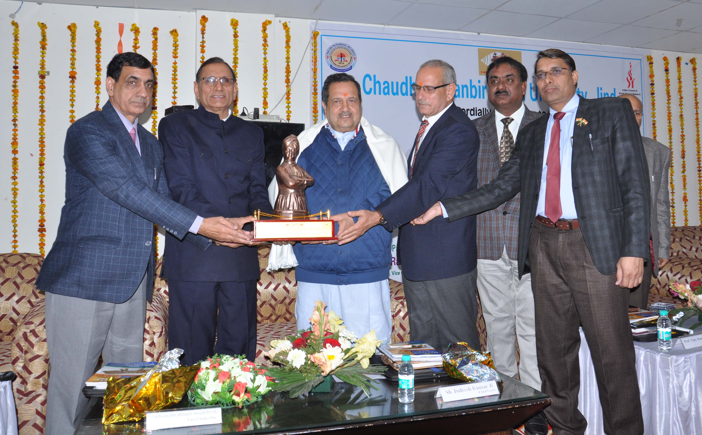
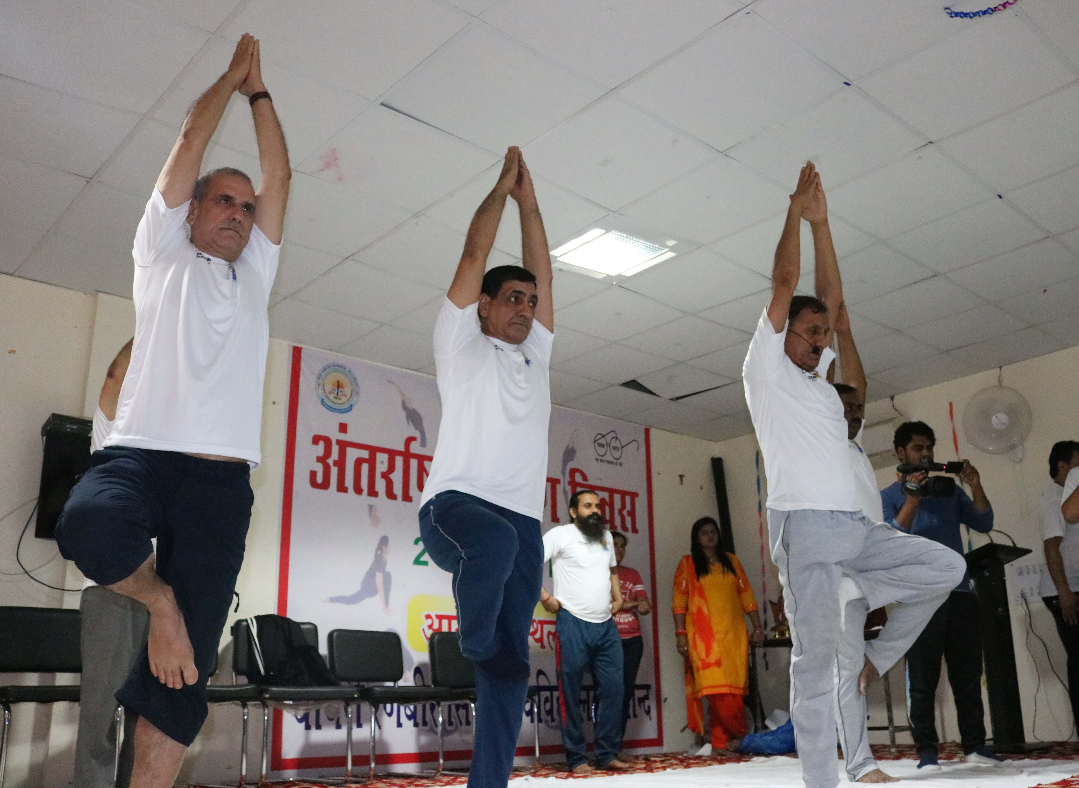

pkS/kjh j.kchj flag fo'ofo|ky;]thUn
Chaudhary Ranbir Singh University, Jind
(Established by the State Legislature Act 28 of 2014 and recognized U/S 2(f) & 12-B by UGC Act 1956)

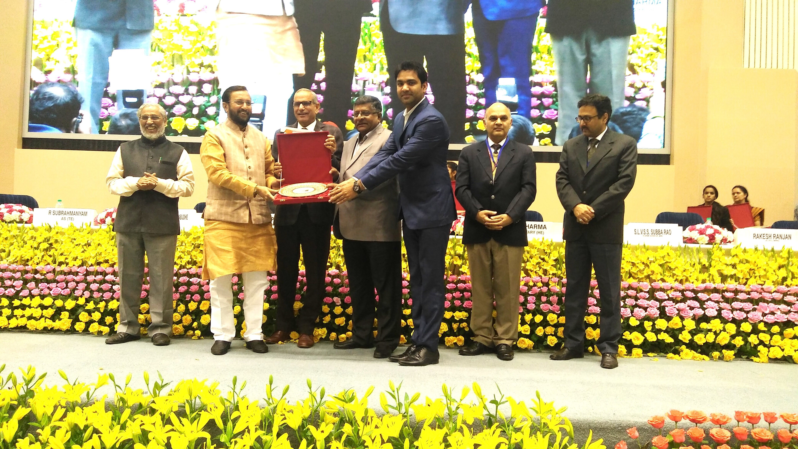

PROSPECTUS

For Admission to B.El.Ed Four Year Professional Degree Programme

Batch- 2018-22

